**Day 74 Goals: what you will make by the end of the day**

**Combine Google Trends with other Time Series Data**

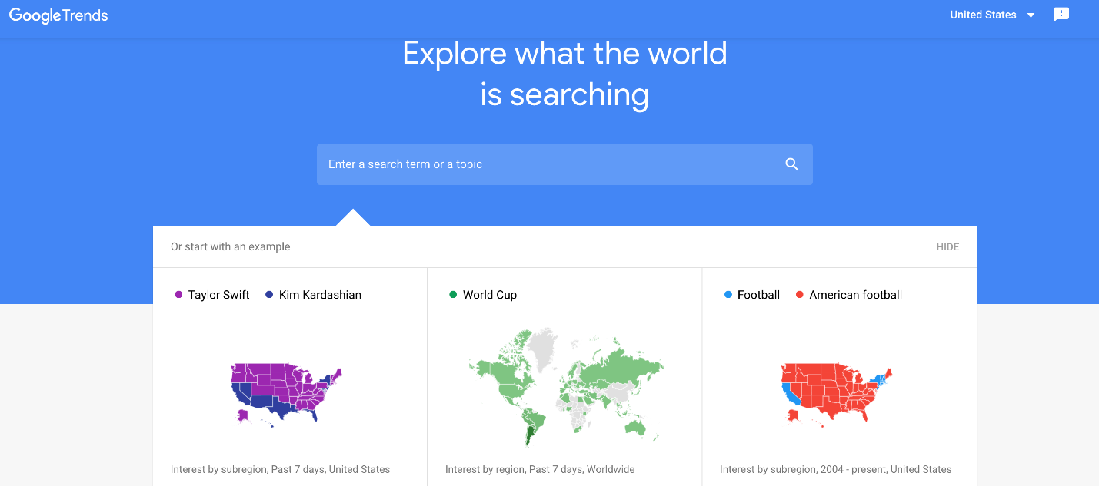

What can the popularity of search terms tell us about the world? Google Trends gives us access to the popularity of Google Search terms. Let's investigate:

* How search volume for "Bitcoin" relates to the price of Bitcoin
* How search volume for a hot stock like Telsa relates to that stock's price and
* How searches for "Unemployment Benefits" vary with the actual unemployment rate in the United States

**What you'll learn today**

* How to make time-series data comparable by resampling and converting to the same periodicity (e.g., from daily data to monthly data).
* Fine-tuning the styling of Matplotlib charts by using limits, labels, linestyles, markers, colours, and the chart's resolution.
* Using grids to help visually identify seasonality in a time series.
* Finding the number of missing and NaN values and how to locate NaN values in a DataFrame.
* How to work with Locators to better style the time axis on a chart
* Review the concepts learned in the previous three days and apply them to new datasets

**Download and add the Notebook to Google Drive**

Download the .zip file from this lesson and extract it. Add the .ipynb file into your Google Drive and open it as a Google Colaboratory notebook.



**Add the Data to the Notebook**

The .zip file also includes 5 .csv files. This is the data for the project. Add these to the notebook.



and let's get this party started!

